C4 Diagrams

# Level 1: Context

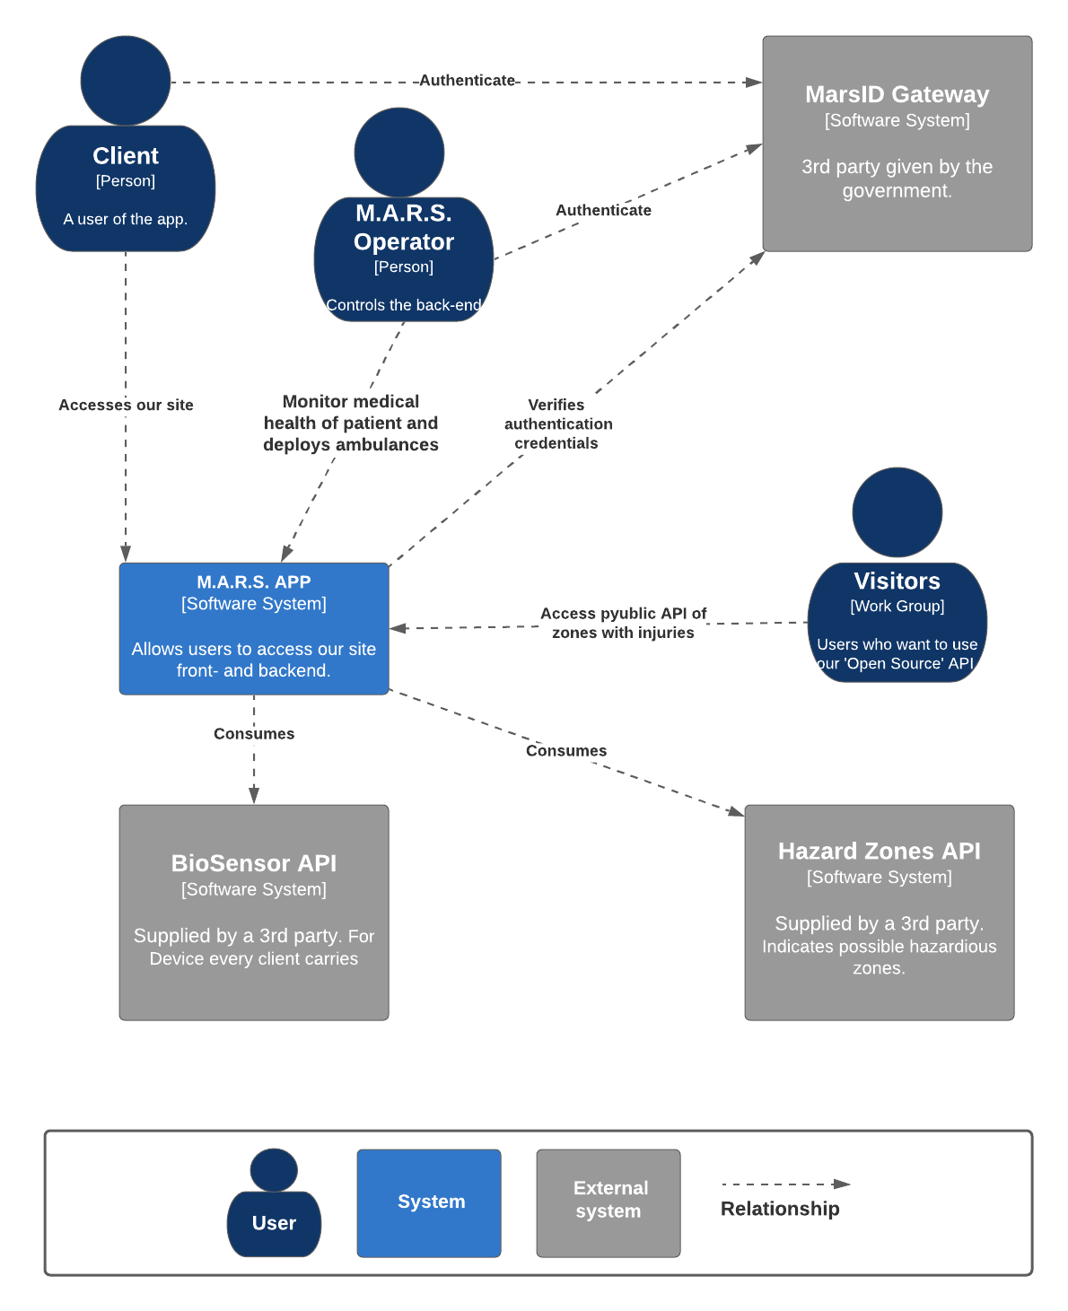

# Level 2: container - M.A.R.S. Application

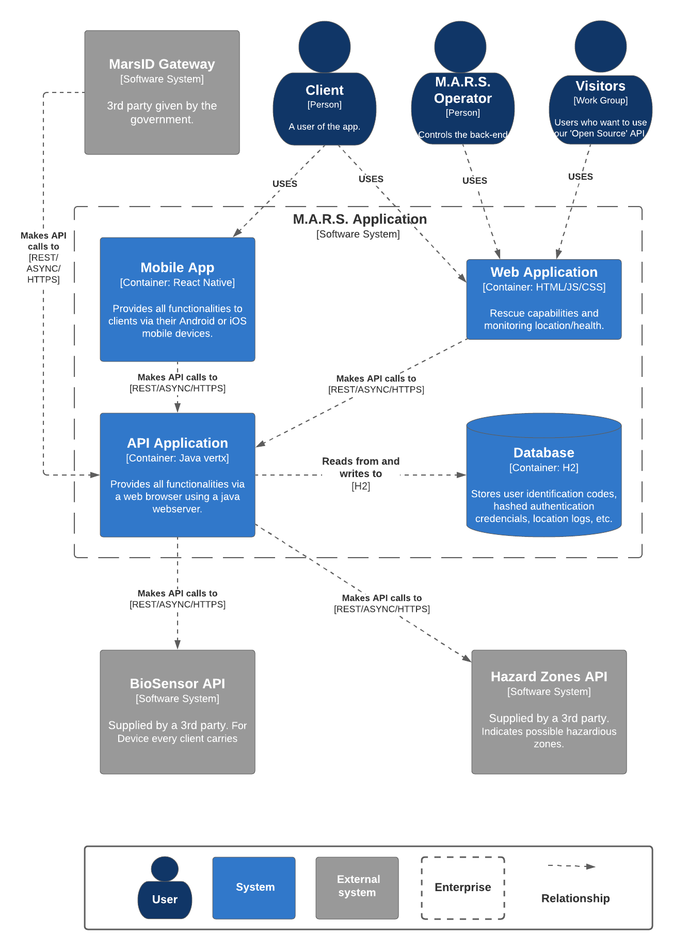

# Level 3: Component - API Application

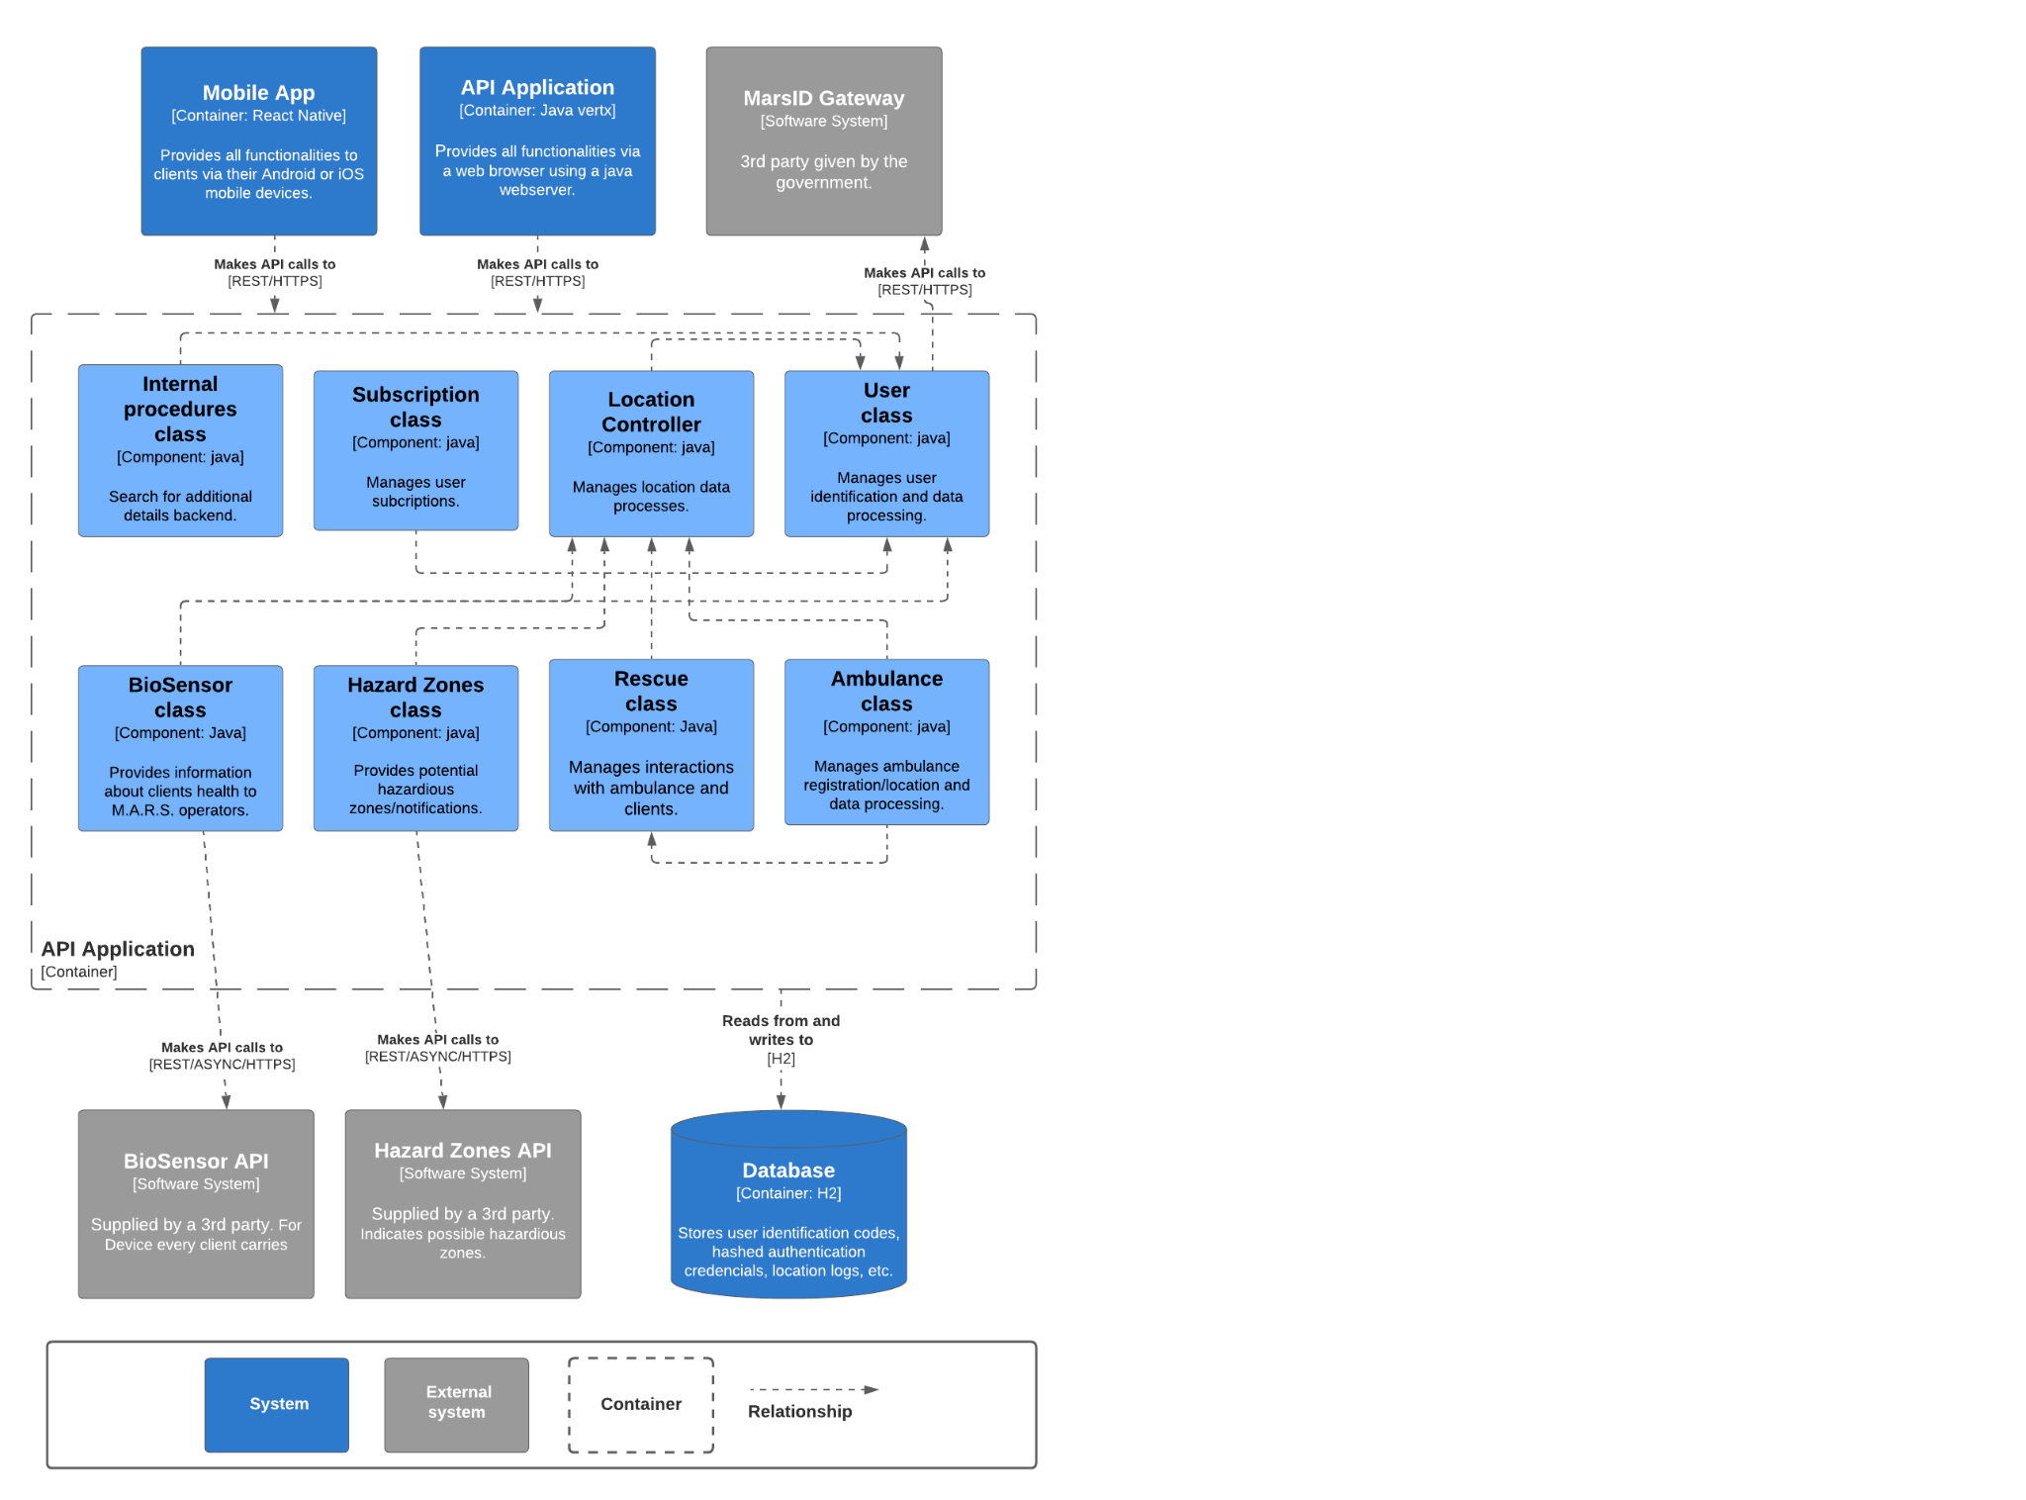

# Lucidchart url’s

L1 & L2 (2 tabs at the bottom): <https://lucid.app/lucidchart/5c4880ea-547c-4321-b760-83d176aec175/edit?viewport_loc=-3243%2C-179%2C2403%2C989%2CZdzqccXC68NS&invitationId=inv_7663a5b1-5393-45fa-a514-37f350cdd1e5>

L3 (separate document):

<https://lucid.app/lucidchart/a31355ab-6908-4618-bbd0-f23ce2f31d6d/edit?viewport_loc=-3955%2C410%2C3683%2C1516%2C0_0&invitationId=inv_583f1eea-ae2a-4c12-af52-602a11b054af>